AGENDA
Rockwall Economic Development Corporation
Regular Meeting of the REDC Board of Directors
Thursday, January 14, 2021—8:00 am
City of Rockwall City Hall Council Chambers
385 S. Goliad St., Rockwall, Texas 75087

- Call To Order
- Guest Recognition
- Open Forum / Public Comment

- Review and Consider Approval of the Minutes from the November 12, 2020 Rockwall Economic Development Corporation Board of Directors Regular Meeting

- Rockwall City Manager’s Announcements
- Review and Consider Ratification of Secretary and Committee Appointments
  - Staff Memo

- Recognition of Rick Carroll, 2020 REDC Chairman
  - Staff Memo

- Chairman’s Remarks for 2021
  - Staff Memo

- Fiscal Year 2021 First Quarter Report of REDC Accomplishments
  - Staff Memo
  - First Quarter Report of Accomplishments

- REDC Prospects Committee Report
  - Draft Minutes from January 6, 2021 Prospects Committee Meeting

- Review and Consider Site Location Partnership Renewal Agreement
  - Staff Memo
  - 2021 Service Agreement
  - Initial Site Location Partnership Service Agreement

- REDC Planning Committee Report
  - Draft Minutes from January 6, 2021 Planning Committee Meeting

- Review and Consider Phase III Infrastructure Update
  - Staff Memo
  - Project Layout
  - Detention Pond Site Plan
  - Updated Schedule
  - 95% Opinion of Probable Construction Costs

- The Rockwall Economic Development Corporation Board of Directors will recess into Executive Session to discuss the following matters as authorized by Chapter 551 of the Texas Government Code:

- Deliberation regarding the purchase, exchange, lease or value of real property pursuant to Section 551.072.
- Discuss or deliberate personnel matters including committee appointments pursuant to Section 551.074.
- Discuss or deliberate Economic Development negotiations pursuant to Section 551.087.
- Take Any Action as a Result of Executive Session

- Any Other News or Announcements
- Adjournment
A quorum of the members of the City Council of the City of Rockwall may be in attendance at this meeting, but no formal action on the part of the City Council is contemplated.

I, Jennifer Hammonds, Office Manager of the Rockwall Economic Development Corporation, Rockwall, Texas, do hereby certify that this Agenda was posted at the Rockwall Economic Development Corporation and at Rockwall City Hall, in a place readily accessible to the General Public at all times and remained so posted for at least 72 continuous hours preceding the scheduled time of said meeting.

The Rockwall Economic Development Corporation Board of Directors reserves the right to adjourn into executive session at any time to discuss any of the matters listed on the agenda above, as authorized by Texas Government Code § 551.071 (Consultation with Attorney) § 551.072 (Deliberations about Real Property) § 551.074 (Personnel Matters) and § 551.087 (Economic Development).

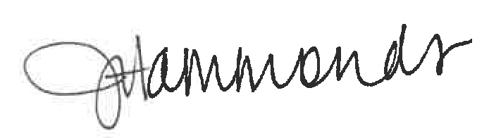
_______________________________________ ____________________________
Jennifer Hammonds, Office Manager Date and Time Removed

Approved: 